**Debugging your angular application in IntelliJ idea**

Here is the steps to enable JavaScript debug mode in IntelliJ.

1. Install the IntelliJ IDEA Support plugin on Chrome. I already add it to Chrome.



2. Install Live Edit plugin in IntelliJ.

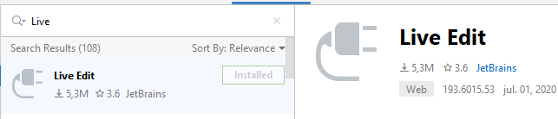

3. In the Settings/Preferences dialog go to Build, Execution, Deployment -> Debugger -> Live Edit. select the "Use JetBrains IDE Support extension for debugging and Live Edit" checkbox.

Please refer the screen shot for other options,

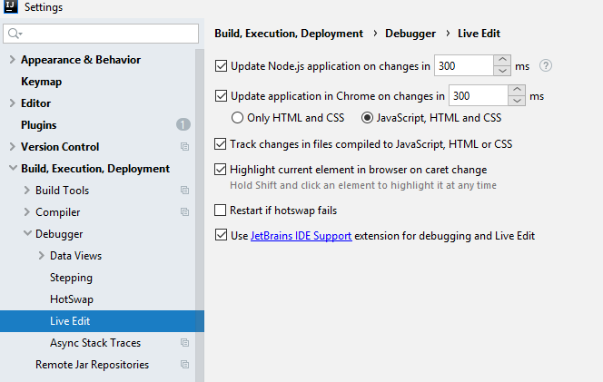

4. Go to Run -> Edit Configurations..., Create a new JavaScript Debug configuration if not exist already. Refer the screen below,

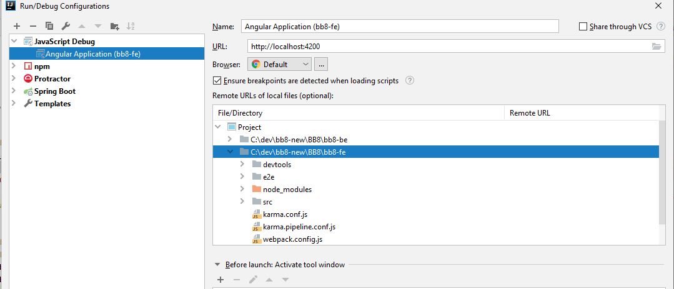

5. Change the default Browser to Chrome,

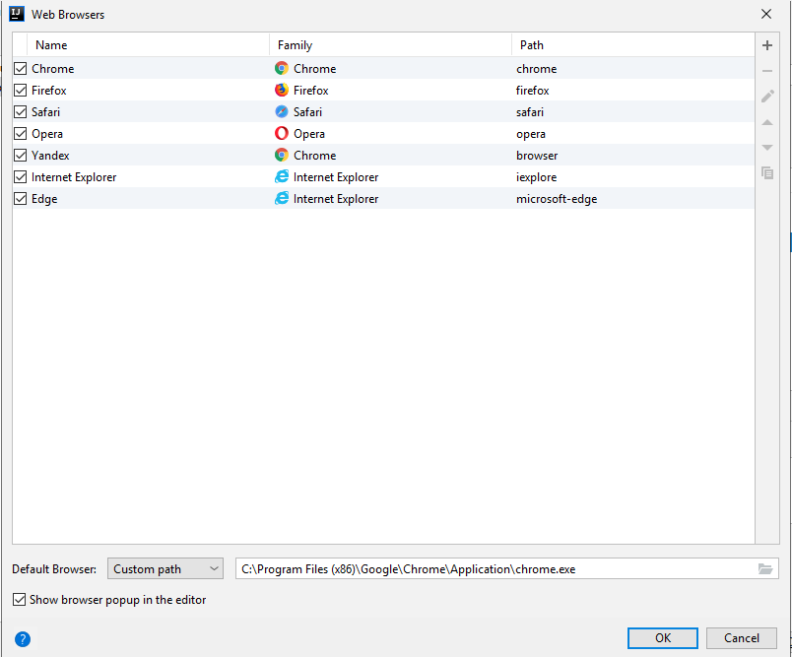

6. Click Ok to finish all the configuration changes.

7. Place breakpoints in your code.

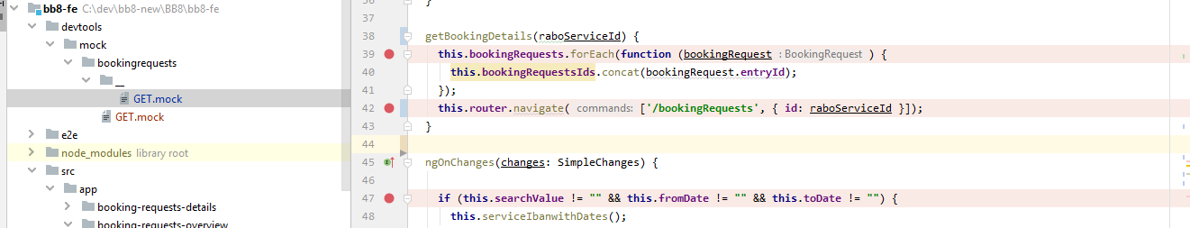

8. Start the Angular CLI server(ng serve) as new session.

9. Start a new debug session.

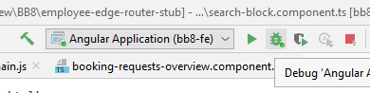

10. If JetBrains IDE Support extension is not installed or mapped with correct port number in Chrome then in Intellij will prompt below warning message.

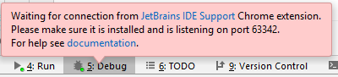

11. Right click the extension in Chrome and select "Options"

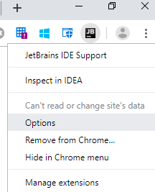

12. Change the port number as **63342** then click Apply.

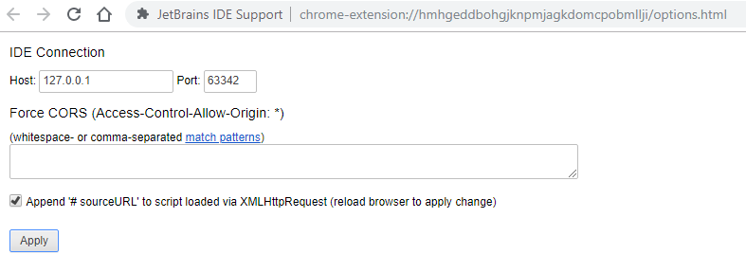

13. Open application in Chrome.

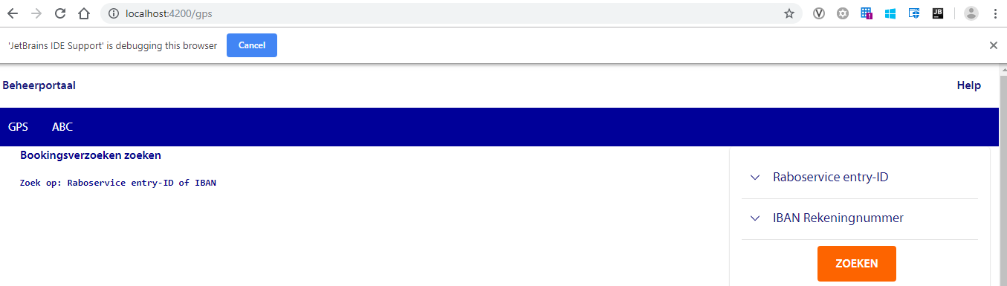

14. Control comes back to editor.

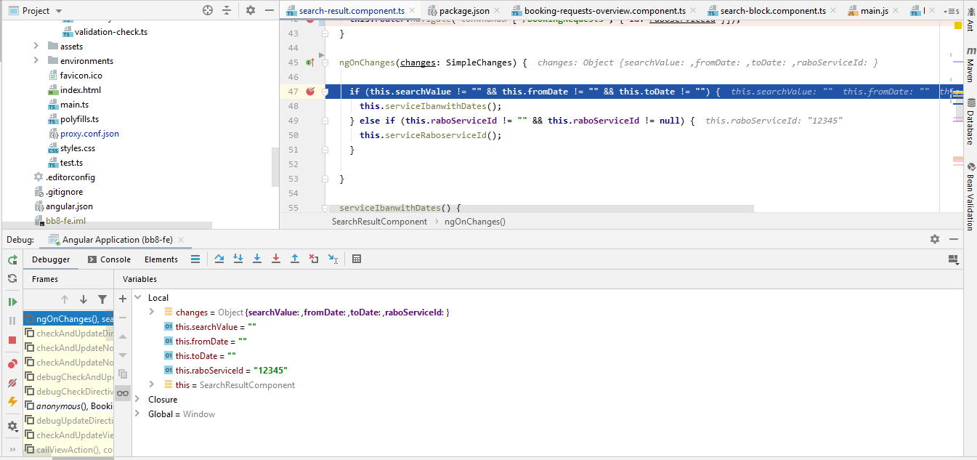

Happy code debugging!!!